To consider when writing scenario texts
Definition. A scenario could be defined as “tool for ordering one's perceptions about alternative future environments in which one's decisions might be played out” (Wright, et al., 2014, p. 325). However, there is no commonly accepted definition. According to Spaniol and Rowland (2019), by analyzing word counts of 77 different definitions of scenarios, there are important common elements: Scenarios are future oriented, they refer to external factors, fashion or trends, the scenario must be possible not impossible and scenario is often written as a narrative, painting a vivid picture of a future, which is shaped by uncertain contextual or structural factors. Further scenarios are often a systematized set and exist as groups, these groups of scenarios are comparatively and meaningful different, for example by a “number of environmental variables” (Spaniol & Rowland, 2019).
Differentiating scenarios. According to Kosow and Gaßner (2008) central for a scenario is the “description of a possible future situation” and that a scenario includes “paths of development which may lead to that future situation” (Kosow & Gaßner, 2008, p. 11). Depending on the included salient characteristics within a scenario a different future S1, S2 can be described. The outer limits of this funnel symbolize future developments which are left out of consideration (Kosow & Gaßner, 2008):
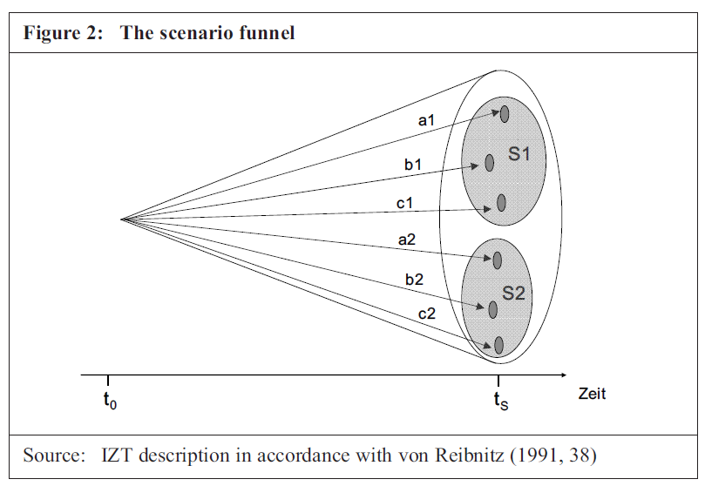
These scenarios could be constructed according to probabilities (include only scenarios with high probability), extremes (best-case vs. worst-case), wish scenarios / also called normative scenarios (like the “Great Transitions”) (Kosow & Gaßner, 2008) or additionally scenarios includes to best- and worst-case scenario a business-as-usual future prediction. Also possible is to construct scenarios according to the “degree of uncertainty” and “degree of impact” or to include only a specific point of view (like experts vs. layperson) (Wright, et al., 2014).
Constructing scenarios. Multiple approaches exist to create scenarios. In the following only two possible approaches are described: According to the approach of Schwartz (1996) several steps are necessary: Identify focal issues, identify key forces, ranking the key factors and driving factors, referring to the most important factors to flesh out scenarios, check how the so constructed scenarios differ and select appropriate scenarios according to plausibility (Mietzner & Reger, 2005). According to Kosow and Gaßner (2008) the scenario process goes in ideal-typical fashion through the five phases:
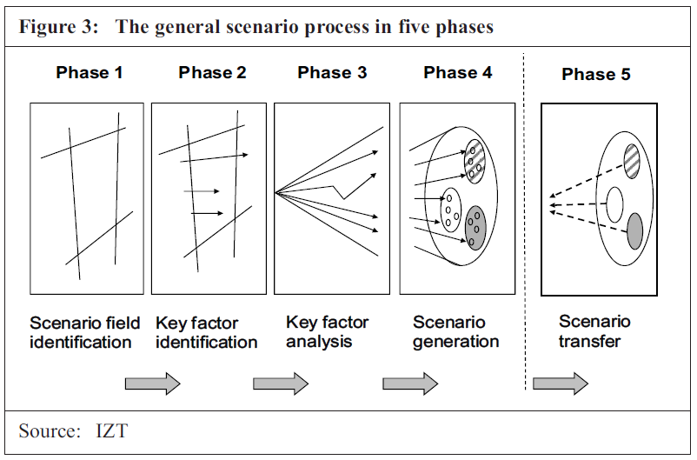
- Scenario field identification: Comprehensive decisions regarding relevancy are to be made and the boundaries of the field which will be taken under study. The purpose of the scenario needs to be defined.
- Key factors: This variables, parameters, trends, developments, and events which receive central attention during the further course of the scenario process.
- Key factor analysis. Aim is to widen the scenario “funnel” in which individual key factors are subjected to analysis, those salient characteristics are selected which are to become part of the chosen scenario.
- Scenario generation: Consistent bundles of factors are brought together, selected, and worked up into scenarios.
- Scenario transfer: Description of the further application and/or processing of scenarios which have been generated.

Quality criteria of constructed scenarios. Depending on the time horizon and the level of complexity and uncertainty that characterize a particular prediction, the scenario may rely primarily on factual information or active speculation in the extreme (Wiebe, et al., 2018):
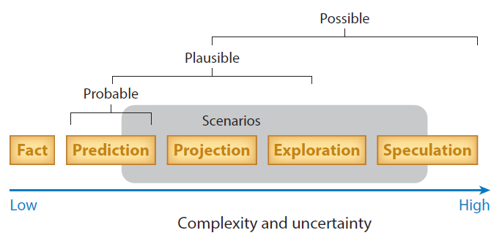
However, central criteria for selecting scenarios is that the selected scenario is (a) plausible (capable of happening), (b) different to the set of scenarios (not simple variations of the same theme), (c) consistent (internal consistent and logical), (d) has utility for decision making (scenario should contribute to helpful insights for the future) and (e) challenging (should contest the common wisdom) (Mietzner & Reger, 2005). Further scenarios should be comprehensible (detailed enough to be comprehensible while not to complex) and best should be “readable” and include elements of fascination and enjoyment and humor (Kosow & Gaßner, 2008).

Evaluate and compare written scenario texts:
At the end central characteristics / factors of scenarios can be summarized according to different topics (adjusted from Wright, et al., 2014) – example for Stratospheric Aerosol Injection descriptive text:
  - Context: Latest information of climate change and its consequences as framing
  - Summary scenario: Stratospheric Aerosol Injection, part of Solar Radiation Management, as possible emergency solution to human driven climate change
  - Time frame: near future (couple of years -> till 2030)
  - Location of technology: not specified
  - Involved actors: not specified
  - Type of scenario: more exploratory than normative (ethical dilemma is no self-evident for participants?)
  - Key assumptions: participants become emotional evolved and reflect ethical, emotional, and acceptance related factors of the technology
- The technologies
  - Stratospheric Aerosol Injection as part of Solar Radiation Management
- The applications
  - Technology can be used to reflect part of the incoming sunlight, so that the sunbeams will not reach earth and therefore enable the earth to cool down
- The drivers
  - environmental forces: rise in CO2 levels temperature climate disaster, uninhabitable planet
  - political forces: part of scientific community and politicians are willing to research and possible implement technologies of climate engineering
  - socio-economic forces: current economic system is driven by consumption, which motivates certain actors to avoid mitigation
  - personal motivation: not change style of living, fear
    - political forces, socio-economic forces, personal motivation only implicit assumptions -> not mentioned in the scenario text
- The privacy risks
  - not applicable in our case
- The ethical issues
  - Negative arguments:
    - risk-transfer argument: transfers the problem of climate change and deployment of the emergency technology to next generations
    - termination problem: possible have to be renewed every year for many decades (100 years or more)
    - informed consent argument: no broad and well-informed consent of those affected
    - moral hazard argument: undermining mitigation efforts
    - slippery slope argument: technology has unknown side effects that
    - hybris argument: humanity plays God
    - loss of intangible argument: whitening of the skies and redder sunset can lead to the deprivation of the human life world
    - …
  - Positive arguments:
    - Arming the future: Research into the technology offers future generations a better basis for decision-making
- No social co-benefits undertaking stratospheric aerosol injection (like increasing bio-diversity using biological approaches of carbon dioxide removal technologies)
- The controls
  - Technology used in case of an emergency solution
  - potential side effects will/need to be resolved before deployment
    - complexity of the climate prevents a final assessment
- The conclusions
  - Technology in the scenario are under research and deployable, so that possible an ethical assessment will not be able to influence the deployment vs. the possible negative side effects are so severe that mitigation efforts are intensified

Typical study design:
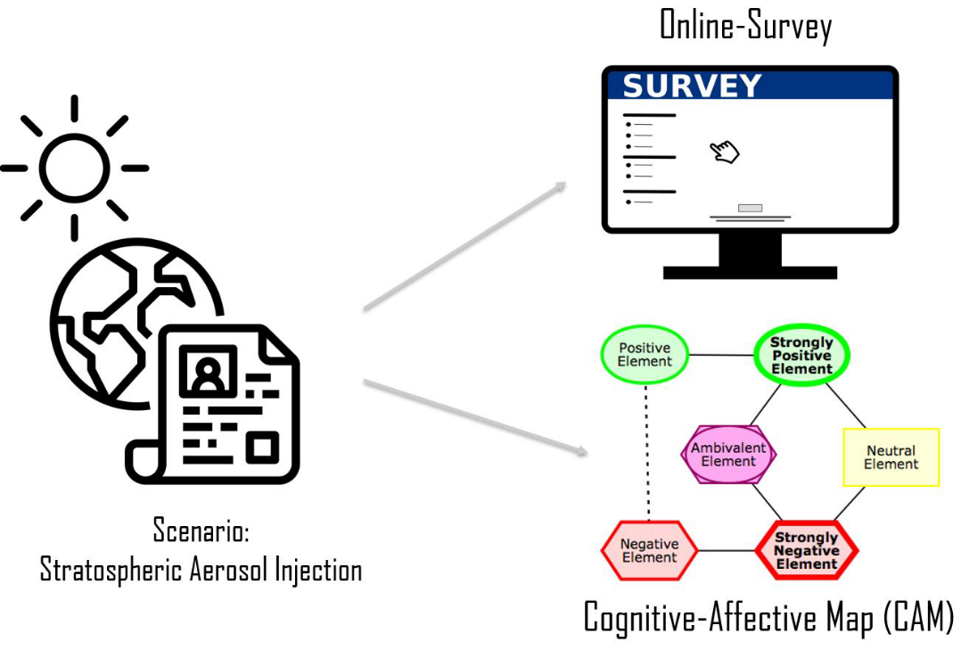

Literature
Kosow, H., & Gaßner, R. (2008). Methods of future and scenario analysis: overview, assessment, and selection criteria. Tech. rep., Bonn: Deutsches Institut für Entwicklungspolitik gGmbH. Retrieved from https://www.ssoar.info/ssoar/bitstream/handle/document/19366/ssoar-2008-kosow_et_al-methods_of_future_and_scenario.pdf?isAllowed=y&lnkname=ssoar-2008-kosow_et_al-methods_of_future_and_scenario.pdf
Mietzner, D., & Reger, G. (2005). Advantages and disadvantages of scenario approaches for strategic foresight. International Journal of Technology Intelligence and Planning, 1, 220–239.
Spaniol, M. J., & Rowland, N. J. (2019). Defining scenario. Futures & Foresight Science, 1, 1–13.
Wiebe, K., Zurek, M., Lord, S., Brzezina, N., Gabrielyan, G., Libertini, J., . . . Westhoek, H. (2018). Scenario development and foresight analysis: exploring options to inform choices. Annual Review of Environment and Resources, 43, 545–570.
Wright, D., Finn, R., Gellert, R., Gutwirth, S., Schütz, P., Friedewald, M., . . . Mordini, E. (2014). Ethical dilemma scenarios and emerging technologies. Technological Forecasting and Social Change, 87, 325–336.

See scenarios of global scenario group: https://gsg.org/scenarios.html

